Week 2: 12 June 2023

**Pre-course Preparation**

* Go through the slides and read the speaker notes to know what to present
* Go through the notes, worksheet and answer key to be familiar with the content
* Download the slides, notes, worksheets, answer key and python scripts on your laptop (there is no internet in the classroom that we will be using)
* Install Python 3.11

### **Lesson Plan**:

| **Time** | **Activity** | **Todo** |
| --- | --- | --- |
| **1500-1505 pm**  **(5 min)** | Welcome | * Brief on curriculum and learning objectives |
| **1505-1530pm**  **(25 min)** | KAHOOT | * About 10 questions * Prizes will be given to Top 3 Students. |
| **1530-1550 pm**  **(20 min)** | Number Guesser | * Using their understanding of if-else statements, students will create a number guessing program |
| **1550-1620 pm**  **(30 min)** | Scissors Paper Stone | * Using their understanding of functions, students will create a basic text-based RPS game * ‘Fill-in-the-blanks’ style exercise (most of the code is provided, students just need to fill in missing code correctly) * Confident students can choose to attempt without the helper code |
| **1620-1630 pm**  **(10 min)** | Debrief | * Recap of everything that was covered today |

### **Appendix A: Number Guesser**

Number guesser: <https://geekflare.com/python-number-guessing-game/>

Sample Product of “Number Guesser” Game:

[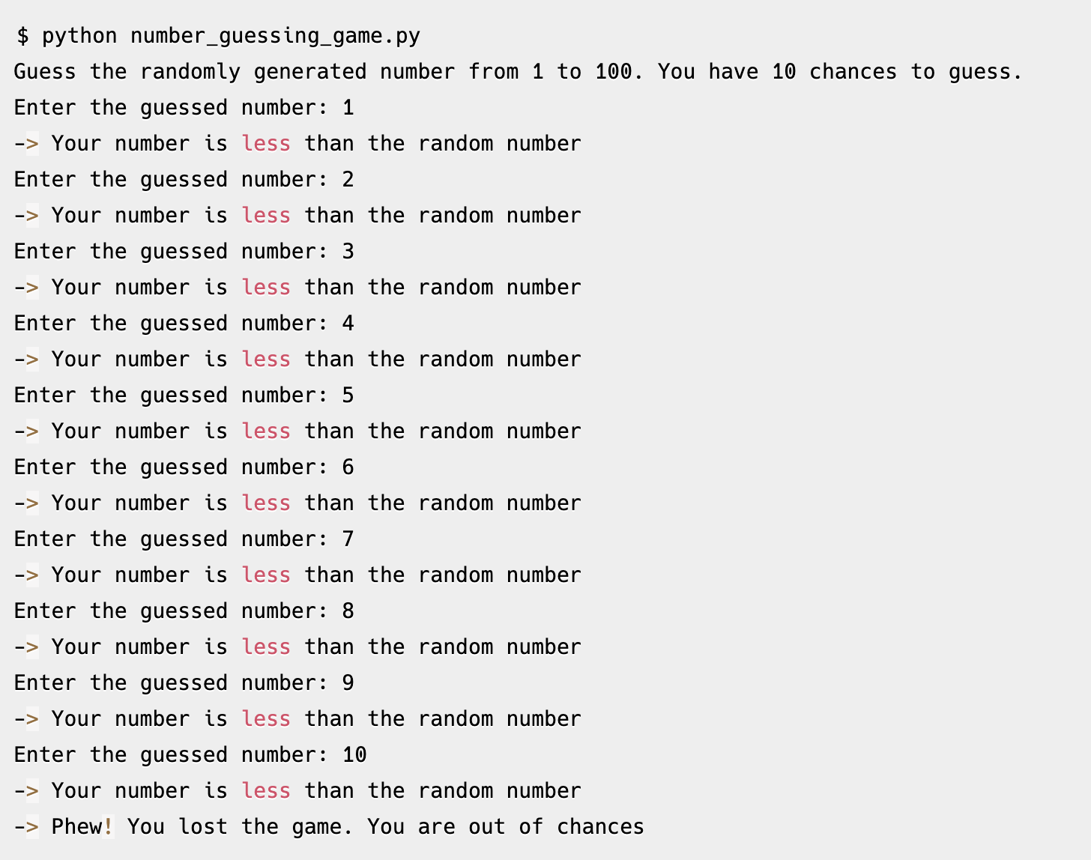](https://geekflare.com/python-number-guessing-game/)

### **Appendix B: Scissors Paper Stone**

Scissors Paper Stone:[Python program to implement Rock Paper Scissor game-GeeksforGeeks](https://www.geeksforgeeks.org/python-program-implement-rock-paper-scissor-game/)

Sample Product of “Scissor Paper Stone” Game:

